Craft Scotland
Collect 2024

Application Pack & Guidance
Simplified Word document for use on screen-readers.
Prepared April 2023.

Contents

Introduction 3
Who should apply? 3
Profile of a Collect maker 4
Why should I apply? 4
Previous participating makers 5
Audience & buyer profile 7
Fair profile 7
Key dates 8
Selection criteria and process 9
Eligibility criteria 9
Selection process 9
Craft Scotland selection panel 10
Equal Opportunities & Access 10
Support with your application 10
Fees & costs 11
Responsibilities 11
Maker responsibilities 11
Craft Scotland responsibilities 12
Marketing & PR 12
How to apply 13
Maker statement 13
Why are you interested in this opportunity? 13
Maker CV 13
Describe the work you intend to exhibit/sell at the fair 14
Photography 14
Frequently Asked Questions 15

Introduction

Craft Scotland is the national development agency supporting makers and promoting craft. A key part of our role is to promote excellence in Scottish contemporary craft locally, nationally and internationally, and to help makers develop their creative and business practice.
Craft Scotland is delighted to announce applications are now open for makers to be a part of our showcase at Collect 2024, which will be the fair’s 20th anniversary edition.

Who should apply?

We are looking for makers who produce works of collectable contemporary craft. Makers should demonstrate an in-depth knowledge of materials, excellence in making (process and skill), and a clear and distinct artistic vision.
For this fair, makers are expected to be categorised within the following materials/disciplines: art jewellery, ceramics, fibre/textiles, furniture, glass, lacquer, gold/silversmithing, stone, leather, paper and wood.
Makers using digital technologies and modern materials within their work are expected to demonstrate that hand skill and craft knowledge is the lead component in both the concept and finished object.
Individual pieces at Collect are to be sold across a range of price points from a minimum of £500. There is no limit on the maximum price. The average price point of a piece is typically several thousand pounds.
The presence of new and emerging talent is an essential aspect of keeping Collect relevant and contemporary. We therefore encourage applications from makers who have not previously exhibited at Collect.
Applications will not be accepted from makers presenting painting, drawing, graphic design, print making (on paper) or photography.

Profile of a Collect maker

Collect showcases makers who push the boundaries of their practice and who exhibit a high level of skill and mastery of the chosen material.
Makers will be at a stage in their practice where they are ready to consider working towards gallery representation, larger scale commissions and inclusion in private or museum collections. You may already be working at that level and are looking for new showcase opportunities.
Collect will provide an opportunity for makers to showcase their work to an international audience. Your work will be seen alongside other prestigious craft galleries and makers from around the world.
Craft Scotland encourage Collect participants to push the boundaries of their practice and produce ambitious work. This might mean creating works using a new or innovative technique, combining two or more elements of your practice, playing with the scale of your work and/or refining elements of your work.

Why should I apply?

The benefits for participating makers are wide-reaching with many makers receiving commissions at the fair, being invited to exhibit with commercial galleries, having work purchased for museum and private collections, and receiving considerable press and social media interest both before and during the fair.
If you think you might meet the criteria for the fair but would like to find out more, then we have prepared some Frequently Asked Questions (FAQ), which can be found at the end of this application pack.
Additionally, if you are thinking about significantly developing your work in a new direction or making large scale, experimental work and you would like to discuss this in advance of applying, then please do get in touch.
We will be holding Collect Application Surgeries, a 20-minute Zoom call with Jo Scott, Head of Programmes, between 10am and 5:30pm on Tuesday 16 May 2023. Register your place, booking essential as limited availability. Please book one slot only:
https://www.eventbrite.co.uk/e/craft-scotland-application-surgeries-collect-2024-tickets-621677091917

Previous participating makers

Collect showcases exceptional work made in the last five years by living artists and designers. Here is a selection of makers who have previously participated at the fair with Craft Scotland.

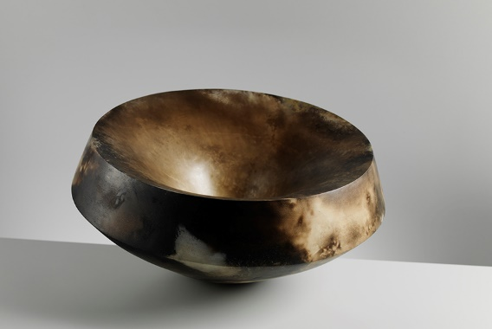 | Mella Shaw makes thought-provoking objects and site-specific installations around environmental themes of balance, tipping points, fragility and loss. With a background in anthropology, museums and the study of material culture Mella is drawn to the way objects can be imbued with shared cultural meaning.  Mella holds a Master’s in Ceramics and Glass from the Royal College of Art (London) and is a visiting lecturer at Central Saint Martins (London).  Mella Shaw showcased with Craft Scotland at Collect 2020, her work was also selected for the fair VIP room and picked up by The Telegraph and The Herald, and attracted interest from private collectors.  Photography by Shannon Tofts.
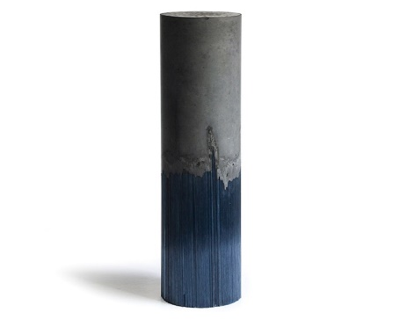 | Harry Morgan’s work highlights the contrasting qualities of glass and concrete, forcing the two into one physically improbable piece. Each glass thread is pulled by hand from a furnace and combined with cast concrete.  Graduating from Edinburgh College of Art in 2014, Harry has a piece in the V&A collection and exhibits regularly. He has won awards including The London Glassblower’s Award for Emerging Talent at the British Glass Biennale in 2015.  Harry showcased with Craft Scotland at Collect 2018 and 2019, his work attracted interest from private collectors and museum collections.  Photography by Shannon Tofts.
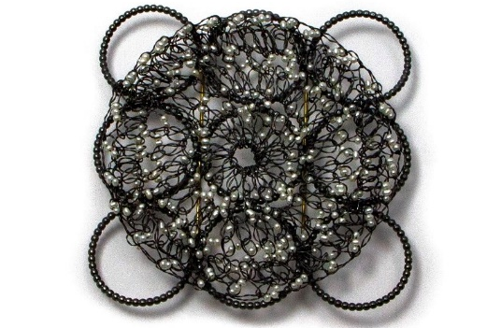 | Susan Cross has designed and made contemporary jewellery for over 30 years, regularly exhibiting both nationally and internationally, and has taught Jewellery & Silversmithing at Edinburgh College of Art since moving to Edinburgh in 1989.  A career landmark and acknowledgement of Susan's practice was winning the Jerwood Applied Arts Award for Jewellery in 2007. In 2017 her work was selected for Schmuck, a highly prestigious international exhibition held annually in Munich, Germany.  Susan showcased with Craft Scotland at Collect 2022, and her work attracted interest from private collectors and the public.  Photography by Shannon Tofts.
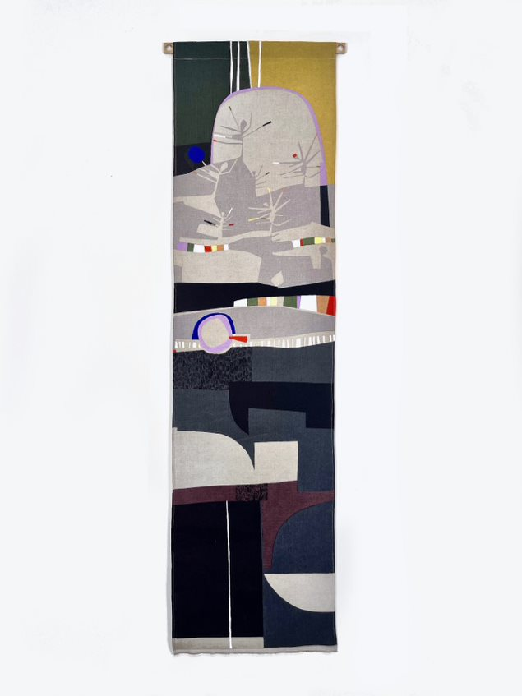 | Eve Campbell graduated in Textile Design from The Glasgow School of Art in 2018 before setting up a print studio in Tighnabruaich. She creates work intuitively to enhance living spaces, primarily creating printed textiles, wallhangings, ceramics and drawings.  Her large-scale paper stencilled, screen printed one-off linen wallhangings are an extension of her sketchbook and drawings. Through paper stencilling, masking and colour mixing Eve’s approach to printing is very spontaneous.  She creates one-off designs that capture the colours, shapes and patterns of Scotland's West Coast nature, landscapes and architecture.  Eve showcased with Craft Scotland in 2023, and her work attracted interest from private collectors and the public both nationally and internationally.  Photography by the artist.

We asked our participants from Collect 2023 about what advice they would give to makers applying for Collect 2024:

“Be bold and ambitious! Often the type of exhibition and their market restrict to some extent what pieces you can make, Collect is one of the few where you can push things up a gear.”

“Be bold! The best part of this happened for me before the fair even began - through creating this ambitious body of work my practice developed significantly and my future as a maker looks different as a result. Be ambitious and regardless of how the show goes for you, you'll have achieved so much.”

“Collect is an amazing opportunity to create work to really push the boundaries of your practice and what you do. The reach of Collect is huge and there is great press from the show so it is a great opportunity to get your best work seen.”

Audience & buyer profile

Collect attracts buyers and collectors from around the world, with over 19,200 visitors in 2023 across in-person and online offerings, with 6,700 unique visitors to Artsy.net, 70% of which were international collectors most of which were from the USA. Significant national and international museums and galleries also attend to acquire pieces for their collections.
Events and gatherings for curators and museums are held during the fair to encourage dialogue and participation. In 2023, 425 people attended the Collect talks programme.
Along with the Crafts Council, each participating gallery and Craft Scotland invite high- profile clients and contacts to the fair.
Previous VIPs include: TRH Crown Prince Guillaume and Stéphanie of Luxembourg, the Duke of Devonshire, the Countess of Harewood, Sir David Attenborough, Bill Amberg, Tricia Guild, Yinka Shonibare MBE, Tony Chambers, Saffron Aldridge, Lady Conran, Stephen Bailey, Tracy Chevalier, Axelle De Buffevent, Sir Peter Bazelgette and Lady Bamford.

Fair profile

Founded in 2004 by the Crafts Council, Collect is the leading international fair for contemporary craft and design. It is the craft sector's premier showcase, bringing together galleries, artists and collectors from around the world.
The 2024 edition celebrates 20 years of Collect. Over that time Collect has been instrumental in defining and growing the marketplace for international collectable craft. Each year, UK and international galleries, dealers or registered groups are selected to showcase at this exceptional fair.
Works span many craft disciplines including ceramics, glass, lacquer, art jewellery, precious metalwork, textiles and fibre, wood and paper to works using non-traditional materials including resin and bone.
The fair’s aim is to introduce and cultivate purchasing audiences to develop and grow the financial and intellectual value of craft at this level.
Collect takes place at Somerset House in the heart of London and occupies the three large, striking galleries that surround the Edmond J. Safra Fountain Court.
The Craft Scotland stand will be a curated space showcasing the work of around 8-10 makers.
“One of the most influential contemporary craft and design fairs, Collect showcases innovative works by living artists and designers” - ELLE Decoration.

Key dates

Key maker dates are highlighted in grey:
*Please note - this is not an exhaustive list of deadlines. There will be further deadlines shared for administration, marketing, and stand design, etc.
Action | Deadline
Collect Application Surgeries  20-minute slots | 10am – 5.30pm, Tuesday 16 May 2023
Deadline for receipt of applications | 5pm, Tuesday 6 June 2023
Craft Scotland selection panel | Late June 2023
Crafts Council advisory panel and final selection of participants | tbc
Applicants notified of the outcome of their application | Early September 2023
Maker contract signed and participation fee due | Beginning of October 2023
Maker preparation event  (details tbc) | Tuesday, 3 October 2023
Various marketing and admin deadlines; including information about work, maker biography, requests for photography | October 2023 – January 2024
Deadline for completion of work for Collect | End January 2024
Delivery of all work for Collect to Edinburgh | Week of 19 February 2024 (exact days tbc)
Collect Previews | Late February/Early March - tbc
Collect open to visitors | Late February/Early March - tbc
Collection of work from Edinburgh | March 2024

Selection criteria and process

Eligibility criteria

You must:
- Live and work in Scotland.
- Produce works of collectable contemporary craft.
- Demonstrate an in-depth knowledge of materials, excellence in making (process and skill), and a clear and distinct artistic vision.
- Be categorised within the following materials/disciplines: art jewellery, ceramics, fibre/textiles, furniture, glass, lacquer, gold/silversmithing, stone, leather, paper and wood.
- Not be represented by another commercial gallery at the fair.

Selection process

A selection panel appointed by Craft Scotland will meet to review all applications to shortlist a group of makers. These makers are then required to be submitted to the Crafts Council’s Advisory Panel for final sign off. All applicants will be notified of the outcome of their application in early September 2023.
Selection for Collect will be based upon the following criteria:
- Makers should be a professional craftsperson. This will be evidenced by maker statement, maker CV and images provided.
- Makers should be working in one or more of the accepted disciplines.
- All work must reflect excellence and the unique vision of its maker, be well-conceived and skilfully made.
- Your work should be suitable for the audience and the fair itself.
- The price point of your work must be reflective of those seen at the fair (please note the minimum indicative price for an individual artwork at Collect is £500, the average price point of a piece is typically several thousand pounds).
- You must not be represented by another commercial gallery at Collect.
Once you have been selected as a participating maker you will benefit from a detailed call with the knowledgeable Programme team at Craft Scotland to talk through your work and the full process for the fair.

Craft Scotland selection panel

Craft Scotland selection panels are made up of national and international industry professionals, such as curators and producers, alongside members of the Craft Scotland team. Applications will be reviewed by the selection panel against published criteria and they will consider the overall group aesthetic and story when choosing makers.
The Craft Scotland selection panel for Collect 2024 will be confirmed in due course.

Equal Opportunities & Access

Craft is culturally significant, essential to our economy and meaningful to our communities. Craft Scotland believes that everyone should have the opportunity to see, enjoy, learn about and participate in craft.
We are committed to equality and opposed to all forms of unfair discrimination.
We welcome applications from those underrepresented in the cultural sector: including but not limited to candidates with lived experience of being Black, Asian, Mixed Heritage and/or a Person of Colour, Refugee, D/deaf, Neurodivergent, Disabled, and/or LGBTQIA+.

Support with your application

If you are interested in this opportunity but feel there are some barriers to participation, please do get in touch. Including but not limited to:
- Caring responsibilities
- Financial
- Accessibility
- Travel
- Slow internet/devices
We would be happy to discuss this with you and see what support is available.
If you think you might be a good fit for the programme and would like to find out more, in advance of applying, then please do get in touch. You can contact Jo Scott, Head of Programmes, Craft Scotland, via email at programmes@craftscotland.org.

Fees & costs

Successful makers will be required to pay a participation fee of £250 (this fee is towards the cost of the stand, administration, staffing and marketing/PR). This fee is due in October 2023 and may be paid as a lump sum or in three instalments (£85/October, £85/November and £80/December).
Craft Scotland will take 50% commission on individual sales up to £5,000 and 35% commission on the proportion over £5,000.
Craft Scotland will take 10% commission on sales made up to three months after the fair.

Responsibilities

Maker responsibilities

As a participating maker here are some of the key things that we expect:
- Meet deadlines as set out in the Key dates section and those issued following confirmation of successful application.
- Discuss and agree final work for the fair with Craft Scotland. You will be expected to provide between three and ten pieces of work (depending on discipline).
- Please note, that while you are encouraged to attend the fair, this is not a requirement. We would ask that for the duration of the fair you are contactable (via email or phone) to assist with any client/press queries that may arise.
- Attend and participate in the maker preparation event.
- Deliver to and collect your work from a Craft Scotland designated location.
- Approve your maker biography and contact information in a timely manner.
- Supply high-quality photographs of your completed Collect pieces, studio and headshots in a timely manner (300dpi, minimum 2000px width).
- Provide a prompt response to any press related enquiries.
- Pay a participation fee of £250 (due October 2023).
- Share your involvement with the Craft Scotland showcase on your website, via social media, email newsletters and to buyers, customers and interested parties.
- Provide feedback as requested.

Craft Scotland responsibilities

As a participating gallery at Collect, representing the participating makers, Craft Scotland will:
- Promote the event and makers taking part on our website and through social media.
- Produce printed literature.
- Maintain communication throughout the project with the successful makers, providing 1:1 support throughout.
- Liaise with the team at Crafts Council regarding the space, press and any opportunities that may arise.
- Liaise with designers regarding stand design. The space will be designed in response to the successful makers and work selected.
- Run a marketing & PR campaign before, during and after the fair to raise awareness of the showcase, participating makers, and Scottish craft.
- Organise return shipping of all works to and from Edinburgh – London.
- Arrange insurance for all work once delivered to Craft Scotland, during shipping (to and from Somerset House, London), for the duration of the fair and for 7 days after work is delivered back to Craft Scotland.
- Curate the space and install makers’ work at the fair (makers are not required to attend the fair during installation).
- Take sales and commissions and liaise with potential clients on behalf of the makers.
- Evaluate and report on the fair.
- Successful makers will be entitled to a free profile on the Craft Scotland Maker Directory for 12 months. Your profile shares your portfolio, maker statement and social media links with curators and audiences alike.

Marketing & PR

Craft Scotland’s Communications & Digital team work closely with the participating makers and the Programme team to create and implement an engaging marketing & PR campaign (before, during and after the fair).
The aim of the marketing & PR campaign is to raise awareness of the showcase, the profile of the makers and contemporary craft from Scotland. The marketing campaign runs across Craft Scotland’s website, newsletters and popular social media channels, and we reach out to our national and international networks to broaden our reach.
For Collect, we work with a PR agency (Oh Really PR) to ensure that we can generate and maximise press and PR opportunities for our Scotland-based makers. We also work closely with the fair’s PR team ensuring that the Craft Scotland showcase is prominent. Craft Scotland is typically one gallery out of 40 galleries and manages to generate high-profile features in key media titles: The Telegraph, Scottish Field, Forbes, Elle Decoration and The Herald.
In 2023, Craft Scotland’s gallery garnered 27 features and significant articles across print, online and social media. Previous media features across the years include; including Hole & Corner, the Guardian, Wallpaper*, House & Garden, The Times and Financial Times. The collective audience media reach via editorial in print, online and social was over 350 million.
Additionally, the Collect web pages had over 90.1k total unique visits and the collective Crafts Council social media following and reach was 718k during the campaign.

How to apply

Applicants should apply through the online application form.
Before starting your application, please be aware that you will need to gather some documents and information. We recommend you prepare your answers on a separate document before beginning your application form, to make sure you have a back-up of your responses.
https://craftscot.wufoo.com/forms/craft-scotland-at-collect-2024-application-form

Maker statement

This is your chance to tell the story behind your practice. We are looking for information about your process, inspiration, materials and professional journey.

Why are you interested in this opportunity?

It is important for the selection panel to understand why you would like to take part in this Craft Scotland opportunity. Please tell us what made you apply and what you hope to get out of the opportunity. We ask this to be sure that what you are looking for is in line with what the fair and Craft Scotland can potentially offer.

Maker CV

Ensure your maker CV is up to date with your latest events, exhibitions, stockists, education and training. This helps us understand more about your creative and business practice and allows us to understand how this professional opportunity will fit in with your career aspirations.

Describe the work you intend to exhibit/sell at the fair

The selection panel need to understand what work you are proposing for the fair. They need to know the number of pieces and the type of work, the scale of the work, what this work is inspired by, whether this will be new or existing work. We ask this to help us determine whether your work is right for this fair.
An indication of price range is also important. Please note that the minimum retail price for an individual artwork at Collect is £500.
The selection panel will review this as a considerable part of your application.
If you are thinking about significantly developing your work in a new direction or making large scale or experimental work, and you would like to discuss this in advance of applying, then please do get in touch.
We will be holding Collect Application Surgeries as a 20-minute Zoom call with Jo Scott, Head of Programmes, between 10:30am and 5:30pm on Tuesday 16 May 2023. Register your place, booking essential as limited spots. Please book one slot only.
https://www.eventbrite.co.uk/e/craft-scotland-application-surgeries-collect-2024-tickets-621677091917

Photography

To strengthen your application, we recommend high-quality photography of your work that is best representative of your practice. Pay attention to lighting, composition and simple backgrounds. Images must be of excellent quality and should be up to 2MB.
A professional headshot and images of you working in your studio will help tell the story behind your practice.
Please include five images of your work – these should be representative of the type of work you intend to exhibit at the fair. If you intend to make and show new work and do not yet have photographs of these pieces, then please upload an image of a piece most relevant to what you intend to show. Please also let us know if an image is of an existing piece, a render or design, or of a work in process.

Frequently Asked Questions

Q. What is the definition of contemporary?
‘Contemporary’ in the context of Collect is defined as work that has been made on or after 1 January 2019.

Q. The material I work with isn’t listed in the show description. Can I still apply?
The materials that people work in is stipulated to Craft Scotland by the Collect fair organisers. If you’d like to talk with a member of the Craft Scotland team, please register for a slot to speak with our Head of Programmes during the Application Surgery or email programmes@craftscotland.org.

Q. I want to make new work that will look quite different to my current practice. When applying, can I send drawings of what I plan to make?
Yes. Please send examples of your current work, and drawings or renders of what you intend to make. Please clearly label your image to inform us if the image is an existing piece or a render/design of prospective work.

Q. What is quality determined by?
Quality will be determined by:
- Artistic expression and intellectual content.
- Individuality and originality of ideas and development.
- Excellence in making, process and skill.
- Presence within significant private collections.
- Presence within public/ museum collections.
- Solo or major group shows.
- Recognition through significant prizes or major commissions.

Q. If I am successful with my application, when will I have to commit to the fair?
If you are successful, you will need to commit to the fair in early October 2023. After this date, there may be a charge to withdraw.

Q. If I am successful, do I need to attend the fair?
Craft Scotland recommends that successful makers visit the fair while it is open to make the most of the fair and its connections and opportunities, however it is not mandatory to do so.

Q. How long do I have to complete my work?
Whilst the fair will take place in late February/early March, we recommend completing your work up to a month in advance to ensure time for photography, pricing and shipping. This should be factored into your working plan when writing your proposal. Whilst Craft Scotland will support you as much as we can, we recommend you ensure you have the capacity to produce your work in time.

Q. Are there many deadlines?
We have outlined the initial deadlines in the ‘Key Dates’ chart. These days are a good starting point for you to consider if you’re able to complete the work for the fair. However, there will be other deadlines and you will be required to submit further information to us throughout the process. The kind of information we will need will be used for the show administration, for marketing and for the stand design.

Q. Do I have control over how the work is displayed?
Craft Scotland works in collaboration with professional interior architects to design the Collect display within the rules and building restrictions of the venue. You will be consulted regularly as part of the process, and we will try to ensure that you feel in informed of and are happy with your display.

Q. Will my work sell?
We cannot guarantee that your work will sell. However, the opportunity to showcase work and make new connections has proved very beneficial for previous makers, leading to longer term opportunities to show and sell work.

Q. My work is quite varied, can I show a broad range of pieces?
We can accept work that has different materials or processes, however, will only display work that is cohesive and displays a strong maker voice.

Q. How much work is involved for a maker in a fair like Collect?
Each maker will be working to different timescales and pressures, depending on if they will be producing new work for the show, and what prior commitments they may have. You should consider the timescales of making new work when you make your application, and your capacity to complete it satisfactorily. There will be a number of additional tasks that we will ask you to complete for the show administration, for marketing and for the stand design.

If you have queries about any of the above, please book in for an appointment for the Application Surgery.

This information is also available in large print Word document.

