Programme Administrator Role
Application Pack and Guidance
Simplified Format
Prepared by Craft Scotland
April 2026

Contents
Key information 3
Key Dates 3
About Craft Scotland 3
Our Vision 4
Our Mission 5
Our Values 5
Role 6
Experience and Skills 7
Person Specification 8
Organisation Structure 9
Organisational Support: 9
Equal Opportunities & Access 10
Support with your application 10
How to apply 11
Interviews 11

Programme Administrator Role
Key information
Craft Scotland is seeking a Programme Administrator to join our team. Working closely with the Creative Director and Learning Manager this new role will provide support across Craft Scotland’s programme.
Job Title: Programme Administrator
Salary: £27,810 gross per annum
Contributory Pension: Craft Scotland contribution 7%; employee contribution 1%.
Contract and Hours: Permanent, Full-Time (35 hours per week).
A minimum of three days per week are to be worked at Craft Scotland’s office.
Location: Studio 6, Castle Mills, 2 Gilmore Park, Edinburgh EH3 9FN
Reporting to: Director
Holidays: 39 days including public holidays.
Craft Scotland’s office closes for three weeks for the Christmas and New Year break (15 days) and for the Easter break (2 days). These are mandated holidays for the team.
Probationary Period: The post is subject to a three-month probationary period.

Key Dates
Application Closing date: 5pm, Monday 11 May 2026
Interview date: Tuesday 26 May 2026

About Craft Scotland
Established in 2008, Craft Scotland is the national development agency for contemporary craft.
We support the whole craft sector, operating across the whole of Scotland and representing all craft disciplines.
Our stakeholders are the professionals working in craft (makers, curators, educators, craft initiatives, organisations, craft businesses) alongside public audiences, media, local and national government and agencies.
Our core work includes presenting craft through exhibitions and events in Scotland and internationally as well as online platforms such as the Craft Directory, through which we connect with audiences to promote and profile Scottish makers.
Our Learning and Engagement programme creates opportunities for professional development and audience development. Through COMPASS we support makers to access skills and connections which support their practice and businesses. With Culture for Climate Scotland we manage the Green Craft Initiative and have a long-standing partnership with Historic Environment Scotland co-delivering projects across Scotland.
We work in collaboration with partners from craft and other sectors across many aspects of the programme. We lead on sector advocacy, emphasising craft’s value and highlighting its connections to national strategies in areas such as education, health, enterprise, tourism and exporting.
We have a committed Board who support the team and provide strategic and financial oversight. We work with a voluntary Advisory Group of makers and craft professionals who provide team and Board with guidance and advice to support development of strategy, and we lead the Craft Development Network, members include curators, academics, and other craft professionals.
We do not operate a venue. Our office is based at Castle Mills in Fountainbridge, Edinburgh.
Craft Scotland is a Creative Scotland Multi-Year Funded Organisation with funding in place until March 2028.
For further information about our work visit Craft Scotland and learn more about our programme.

Our Vision
To make Scotland a place where craft plays a vital role in our society and is valued as culturally important and essential to our economy.

Our Mission
We have three intersecting mission pillars:
(i) Presenting Craft: we showcase the best of Scottish contemporary craft locally, nationally and internationally to support the sector to increase, diversify and develop the audience for craft
(ii) Learning and Engagement: we support makers, educators and the craft sector to develop successful and resilient craft careers and ensure equitable access by diverse audiences to the wider benefits of craft
(iii) Leadership and Advocacy: we advocate for contemporary craft in Scotland, promoting the value of the sector to public audiences and stakeholders who can help us to create strong economy and infrastructure for craft

Our Values
- Creativity: we believe in the creativity, talent and skill of makers and craft professionals living and working in Scotland.
- Inclusion: we actively engage with current social issues and work to ensure our programme is responsive to and fully representative of society.
- Integrity: our decision-making processes are open, transparent, and fair, and we continuously seek feedback from the community.
- Commitment: we will drive change to ensure better economic opportunity for makers and wider craft ecology through creating opportunities, partnership working and advocacy.
- Collaboration: we work respectfully and collaboratively to achieve our shared community goals and expand our collective learning.
- Legacy: continuing to work towards creating a more diverse and inclusive sector that supports equitable participation for professionals and audiences.

Role
The Programme Administrator will provide essential support for the programme, working closely with the Creative Director and Learning Manager and across the full team at times.
The role ensures the smooth and professional delivery of activities through co-ordination of day-to-day administration, travel and event logistics, and assistance with the practical set-up and running of events.
This post is a key first point of contact for programme participants and audiences and is important for maintaining efficient operations and clear communications across our programme.

Key Outputs

- Administration of open calls and opportunities which includes organising info packs, supporting selection panel processes

- Diary management for Director, Creative Director and Learning Manager

- Supporting programme delivery and logistics which includes forward scheduling, booking accommodation and travel for makers, team and groups

- Supporting event management which includes creating schedules and staffing plans, organising event ticketing and liaising with venue staff

- Point of contact for audience and maker queries

- Help in the set up and staffing of events and exhibitions (day, evenings and weekends)

- Administration of data collection for reporting and evaluation which includes circulating online surveys and in person surveys at events

- Handling contracts, invoices, and relevant documentation

- In addition, the Programme Administrator will:

  - Proactively support the Equalities, Diversity and Inclusion and Climate Action work of the organisation

  - Report on progress at regular intervals and advise of any risks arising in a timely manner

  - Support the wider team with other duties as required

  - Develop and maintain positive working relationships, ensuring that colleagues and stakeholders are treated fairly and with dignity and respect

  - Be committed to and ensure familiarity with health and safety policies and procedures

  - Occasional out of hours working and travel will be required
Experience and Skills
Essential
- At least two years’ experience supporting project planning and delivery of arts or cultural events or other professional events in areas such as luxury retail, hospitality or travel.

- Experience supporting needs of diverse audiences.

- Understanding of current regulations in health and safety, safeguarding, GDPR.

- Strong communication skills by email and in person.

- Strong digital skills, including proficiency in Microsoft 365 (e.g. Word, Excel, Outlook, Teams) and the ability to quickly learn new systems and software.

- Basic financial admin experience.

- Be able to handle conflicting deadlines and use your initiative.

Desirable
- One to two years’ experience supporting creative practitioners and/or educators.

- Knowledge of the craft, design, and/or visual art sectors.

- Driving License.

- Experience using a range of digital platforms for collaboration, project management, event delivery and booking systems (e.g. SharePoint, monday.com, Eventbrite, Zoom). Training will be provided where required.

- Basic AV knowledge.

Person Specification
Working across the Presenting Craft and Learning and Engagement programmes, the role requires an ability to co-ordinate events and activities simultaneously and keep everything on track to deadlines.

- The Programme Administrator should demonstrate awareness of and sensitivity towards the varied and changing needs of those involved in our programme.

- Be open to collaboration and support the work and values of our partners which range from national bodies to small, local charities.

- Be enthusiastic in representing Scottish contemporary craft to different audiences.

- Demonstrate proven ability to work independently and as part of a team.
- Willing to travel nationally and to attend out of hours events (Craft Scotland and sector events).

Organisation Structure
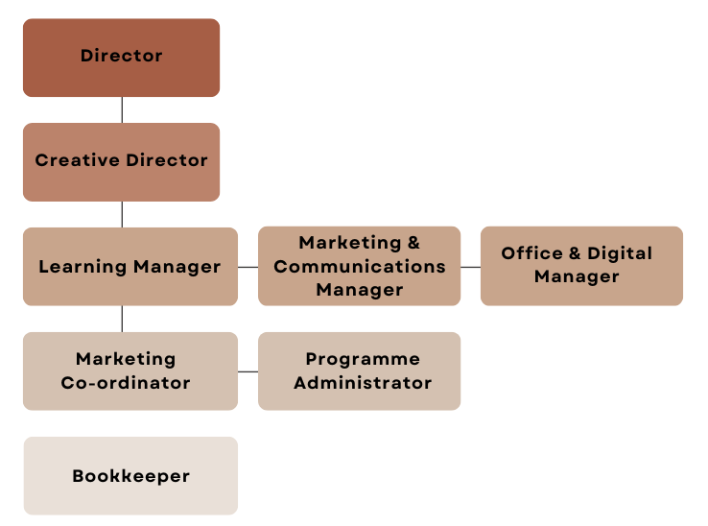

Organisational Support:
Craft Scotland cares about building a great workplace for our team. We are committed to Fair Work which is reflected in our procedures. We cultivate a collaborative working environment in order to support development and delivery of a high-quality programme for our stakeholders.
We support our team’s training and professional development to ensure we can provide excellent support to our sector and to allow team members to progress and develop within their career. With guidance from your Line Manager, you will create an annual Personal Development Plan identifying areas for development including in-house learning opportunities, studio visits, coaching, training and reading. Additionally, you can take 4 Research Days across the year to focus on an area of interest and then share this learning with the team.
We support team members’ wellbeing, offering 39 days holiday each year and wherever possible, accommodate team members’ needs across the working week e.g. for childcare or other caring responsibilities flexible hours can be negotiated. We offer wellbeing vouchers to the value of £50 each year and access to Edinburgh Leisure CAP scheme.
Hybrid or home working is supported for a proportion of the working week. We do not pay overtime, but Time Off in Lieu (TOIL) can be claimed.
The Board keeps in touch with the team, meeting over the year for training, strategic planning and informal networking.
We offer a contributory pension scheme (Employer 7%, employee 1%).

Equal Opportunities & Access
Craft is culturally significant, essential to our economy and meaningful to our communities. Craft Scotland believes that everyone should have the opportunity to see, enjoy, learn about and participate in craft.
We are committed to equality and opposed to all forms of unfair discrimination and to building a diverse and inclusive workplace where everyone feels valued, respected, and is empowered to thrive. We welcome applications from candidates from all backgrounds and believe that a wide range of perspectives leads to better ideas, stronger teams and creates positive environments for learning and development across all our work. We particularly encourage applications from underrepresented groups and are dedicated to making our recruitment process as inclusive and accessible as possible.
Craft Scotland is an Equal Opportunities Employer and our offices at Castle Mills are accessible.
Craft Scotland Equalities, Diversity & Inclusion policy outlines our commitments in more detail.

Support with your application
We are happy to help if you have any questions, or if you require any assistance to complete your application or to attend an interview. You can get in touch directly with Irene Kernan, Director at irene@craftscotland.org to talk through any support you need.
This application pack is available in simplified and large format.

How to apply
Applicants should apply through the Craft Scotland online application form.
Please upload a current CV (maximum 2 x A4 pages).
Include contact details for 2 relevant referees (Name, Organisation, Job Title and Email) and briefly describe in what capacity they know you. We will not contact referees without informing you first.
We also ask you to complete our Equal Opportunities Monitoring Survey (voluntary). This survey can be completed anonymously. It does not form part of your application and will not be used in any part of the selection process but it is useful for our reporting to funders and understanding our audience.

Interviews
Interviews will take place on Tuesday 26 May 2026 in person at Craft Scotland’s office.
The interview panel will include Craft Scotland’s Director, Creative Director and Learning Manager.
Craft Scotland will reimburse reasonable travel/care costs for in-person interviews.

